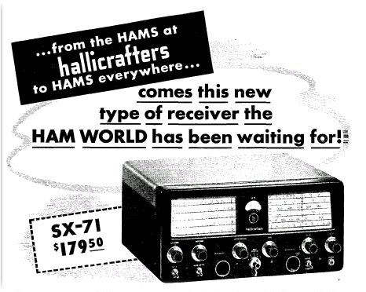
I decided to take a '2nd' look at the SX-71. While it played quite well I never felt like it was doing all that a receiver with 3 IF stages should do. Front end seemed sensitive enough, but overall gain and AGC action, while a little better than 'most' receivers with 2 IF's like the Hammarlund HQ-100, Halli SX-110 etc, just didn't seem to really have the "punch". After I overhauled Don's National NC183D that had 3 IF's and a circuit design quite similar to the SX-71 that opinion was further reinforced. In that set I had to change a couple resistors (per factory recommendation) to decrease the gain slightly as it was unstable.mp!
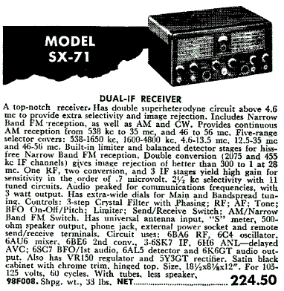
So anyway, I sat down with the schematic and tube manual to see if I could determine why it's gain seemed so modest for the tube lineup. Didn't take me long to spot it. The 2nd IF stage had it's tube cathode biased very high and an unusually low screen Voltage on the screen grid. So, I dug out ye old trusty soldering iron and set the cathode resistor and screen Voltage to the same level that the 1st and 3rd IF stages use, which is a normal and expected value. Voila! Gain and AGC action came up to my expectations. It won't affect overall sensitivity/noise figure as that is mostly determined by the RF amplifier and first mixer stages. What it does affect, especially on the higher frequencies is how well the AGC performs and how high you need to turn the volume on the weak stations. Before you always had to 'crank it up' on weak stations on the 17 & 21MHz bands, which is why I nearly always used the Ameco Nuvistor preamp over 15 MHz. The thing really sounds good now and that is without the preamp!
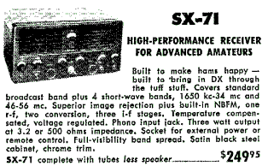
The SX-71 is claimed to be the first double conversion set on the market. They also wanted the selectivity and perhaps a 'little' extra gain that an extra IF amplifier gave them. I can think of no explanation of why the receiver was purposely 'tamed down' by crippling the 2nd IF and putting coils that are sub par for the BCB band in an otherwise hot set. Perhaps 3 IF stages were so rare back then that they felt the "little" added boost was sufficient, while now days we are used to all receivers having several AGC controlled stages that give superb AGC action.

